MBBA SUMMER PICINIC
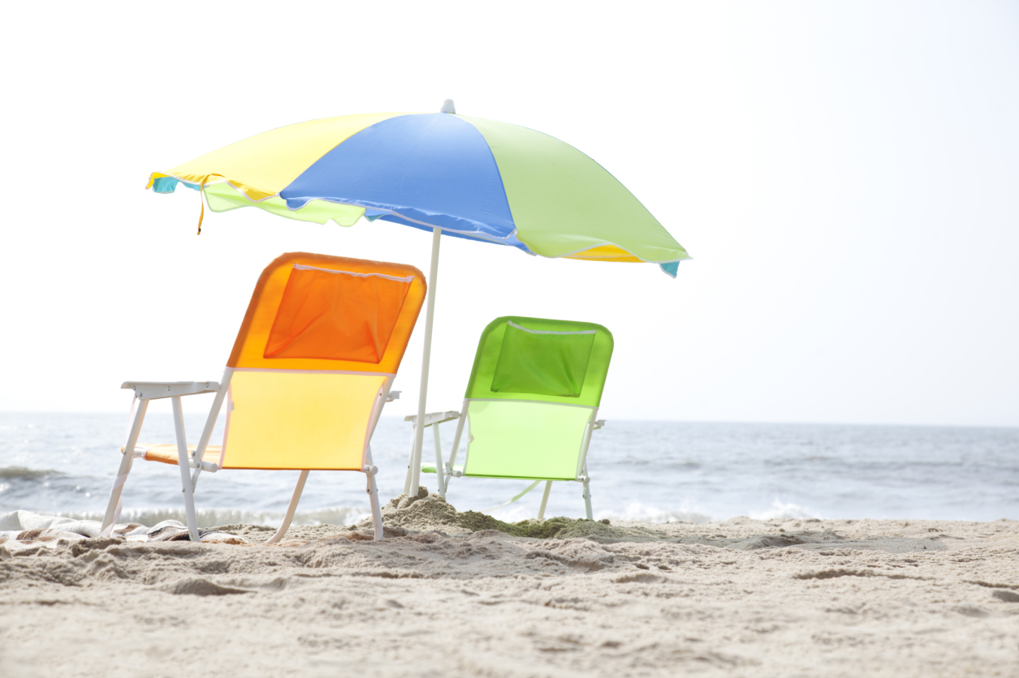

Sat. July 9th, 2022 arrive 1pm eat at 2pm

Burgers and Brats will be provided please bring a dish to pass

Reminder to bring item for FUN auction
  - RSVP: bigmaplefarm90@yahoo.com
  - Richard & Marylin Kropf 616-894-1249
  - 5757 Bartonville Rd Belding, MI 48809

