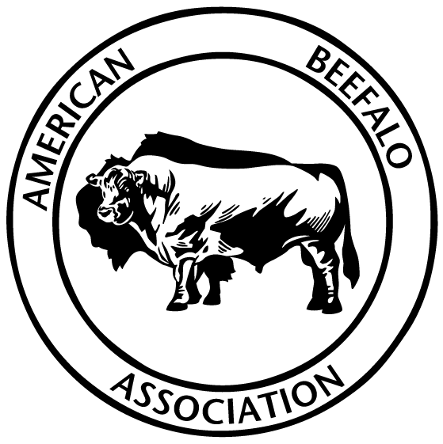 | AMERICAN BEEFALO  ASSOCIATION

SHOW AND SALE ENTRY Please use a separate form for each Animal
Entry Fees are $50.00 per animal if received by February 10, 2022.
Late entries are $75.00 if received by March 10,2022
From March 11, 2022 to the Show and Sale Date entry Fee is $100.00
There will be no other sales commission on the sale of the animals.
All animals will be required to have a permanent USDA approved I.D. tag and current Health Papers. All Bulls over 12 months of age are required to have a negative Trich test.

EXHIBITOR Information
Full Name: |  |  |  | Farm Name
 | Last | First
Address:
 | Street Address |  |  |  |  |  |  |  | Apartment/Unit #
 | City |  |  |  |  |  |  | State | ZIP Code
Phone: |  |  |  |  | Email

ANIMAL INFORMATION
NAME OFANIMAL |  | REG#

DATE OF BIRTH |  | BISON CONTENT: |  | Sex: ______ Bred: _____ | Polled_____ Horned _______

Expected calving date |  | Bison Markers: ____________________________

Service Sire

Sire: |  | Bison Content | :

Dam: |  |  |  | Bison Content:

Show only
Show and Sale |  | :

Sale only

