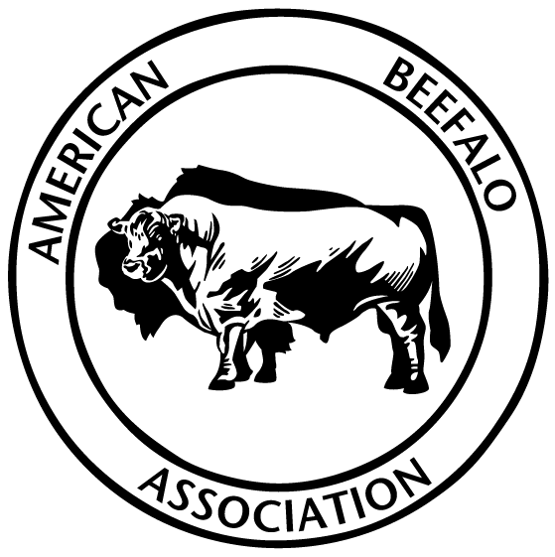 | AMERICAN BEEFALO  ASSOCIATION  MAIL TO:  14481 Millersburg Rd SW  Navarre, OH 44662

SHOW AND SALE ENTRY Please use a separate form for each Animal
Entry Fees are $50.00 per animal if received by February 25, 2021.
Late entries are $75.00 if received by March 10,2021
From March 11, 2021 to the Show and Sale Date entry Fee is $100.00
There will be no other sales commission on the sale of the animals.
All animals will be required to have a permanent USDA approved I.D. tag and current Health Papers. All Bulls over 12 months of age are required to have a negative Trich test.

EXHIBITOR Information
Full Name: |  |  |  | Farm Name
 | Last | First
Address:
 | Street Address |  |  |  |  |  |  |  | Apartment/Unit #
 | City |  |  |  |  |  |  | State | ZIP Code
Phone: |  |  |  |  | Email

ANIMAL INFORMATION
NAME OFANIMAL |  | REG#

DATE OF BIRTH |  | BISON CONTENT: |  | Sex:_______ Bred: _____ | Polled_____ Horned _______

Expected calving date |  | Bison Markers:____________________________

Service Sire

Sire: |  | Bison Content | :

Dam: |  |  |  | Bison Content:

BANQUET TICKETS | $25.00 each | QTY ________ TOTAL

ENTRY FESS | $50.00 by 2-25-21 | QTY__________TOTAL____________

ENTRY FEES | $75.00 2-26 to 3-10-21 | QTY__________TOTAL

ENTRY FEES | $100.00 3-11 to 3-28-21 | QTY_________TOTAL

TOTAL ENCLOSED

